Final Project Design Phase
Computer Science - Week 11
Oct 3, 2026 - Version 0.0.4

For complete instructions and project ideas, refer to the assignment in Canvas. Specifically, review the final project requirements before you continue below. If you have not reviewed the project requirements in Canvas (you might have to go to the modules view and check the current or past week's content), you will not be able to properly complete the parts below. In addition, it may be helpful to review the information on this Drafter documentation page.

0) Project Planning and Preparation
Successful programmers spend time planning before they begin coding. After reviewing the project requirements, answer the following questions to help guide your design and development process.
- What concepts from class or previous assignments might help you complete this project? Which programming concepts (loops, conditionals, lists, classes, etc.) do you expect to use? What programming skills do you want to improve while completing this project?
I expect to use loops, conditionals, lists, and classes, because of all the things my website will need to accomplish. I want to improve my ability to plan and organize large programs.

- Which parts of the project do you expect to be the easiest for you? The hardest? Why?
The easiest will be creating the actual functions using AI, and the hardest will be understanding each component and structuring the website in a way that makes sense.

- Even though you have not yet designed the final project, estimate which tasks will likely require the most time and effort? Which features or components should be implemented first?
I think the creation of dataclasses and the filling in of background info into the program should be implemented first. I think that creating the conversions needed in my program will be the hardest thing to perform.

- What distractions might interfere with your work and how will you minimize them? What resources will you need available while working? What questions, if any, do you still have about the assignment requirements?
I will need access to the LLM, and will want to start doing the coding early so I don't get behind on it.

1) Site Diagram
Create a mock-up of your planned website. We suggest you make the mockup on paper, although you can also use software like PowerPoint or Slides to make a mockup. There is other design software that could also be used, but we strongly encourage you to keep it simple. Do not spend more than 15-30 minutes detailing the mock-up. Your goal should be to make a very quick and dirty diagram, to show that you have some kind of idea.

We recommend drawing each page as a rectangle, and laying out the text, buttons, and other components inside. Then, use arrows to indicate links between pages. Label each page the way you will name each function, and then put labels on the arrows to indicate what the button links. Also write down any parameters that should come into the pages.

In addition to the pages and routes, write down what fields your `State` will have, both their names and types. Think clearly about what data will need to be persistent across the entire website.

Add photo(s) or screenshot(s) of your website mock-up and labeled diagram on the next page.

Create an automated chemistry assistant that takes balanced reaction equations, starting reactant masses, and a harvested product amount to determine the limiting reactant, theoretical yield, and percent yield. To avoid manually compiling atomic mass tables or writing custom string tokenizers, use the chempy library to parse molecular formulas into exact molecular weights and verify reaction stoichiometry against compound data from the NIH PubChem Database. The program outputs an organized breakdown of limiting reagent status, product yields, and remaining masses of unreacted species.
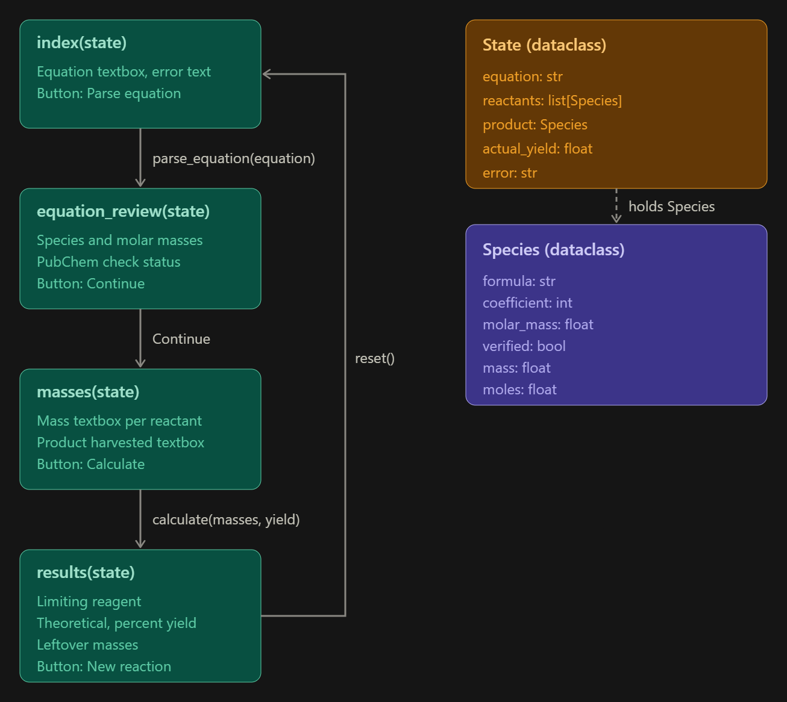

2) Implementing Requirements
This table should serve as a draft for how you will implement the requirements into your final project. You may change your ideas later on, but your final site must fulfill all the requirements.

Requirement | Implementation
Purpose/Functionality  A 1-2 sentence description of the purpose or functionality of your site | Create an automated chemistry assistant that takes balanced reaction equations, starting reactant masses, and a harvested product amount to determine the limiting reactant, theoretical yield, and percent yield. The program outputs an organized breakdown of limiting reagent status, product yields, and remaining masses of unreacted species.
State Dataclass Attributes  Minimum of 4 attributes, one of which must be a list/dict of instances of your second dataclass.  Briefly describe each attribute, its type, and how it will be meaningfully modified throughout the site. | Equation: a string representing a chemical reaction, input by the user  Reactants: a list of Species representing the reactants and their critical info  Products: a list of Species representing the products and their critical info  Actual_yield: a float representing the amount of product actually produced by the reaction  Error: a string representing an error message if something goes wrong with the program or inputs are inorrect
Second Dataclass  Your second dataclass, including its attributes, their types, and how they will be meaningfully modified (if they are modified) | Species:  Formula: a string showing the compounds chemical formula  Coefficient: an integer representing the molar coefficient of the species  Molar_mass: a float showing the molar mass of the compound  Verified: a bool representing if this is a verified compound from the information given  Mass: a float, the mass of compound  Moles: a float, the moles of the compound
Routes (minimum 7)  The names of your route functions | Index, parse_equation, equation_review, masses, calculate, results, compound_info, reset
Pages (minimum 5)  A brief description of the pages in your site | index(state), the home page, including a textbox for the equation and a create equation button  equation_review(state), a breakdown of the equation into species with information  masses(state), a page requiring the user input on mass information of each species, and the target product  results(state), a page displaying results about the equation  compound_info(state), a page used to gather information about reactants and products, as well as display tables with info about species
User Input (minimum 3)  Description of user input components (TextBox, TextArea, CheckBox, or SelectBox) and their purposes  For more information on these input types, see Drafter Documentation. | TextBox: user input chemical equation.  TextBox: mass per species  TextBox: completion percentage
If Statements (minimum 3)  Brief description of what will be evaluated in your if statements and how they will meaningfully change the logic of the site | An if statement which will determine species name by comparing it to existing data.  An if statement which will determine if masses of reactants or products are 0.  An if statement displaying an error message if user inputs are formatted incorrectly.
Loop (minimum 1)  This loop must iterate over the list/dict of dataclass instances in your State attribute.  Description of this loop and why it is meaningful to the site | A loop which iterates over the species list of reactants and products from state to gather information about the species and perform calculations using the list.

LLM Conversation
If you used an LLM in any part of this work, copy and paste every part of that conversation below. Otherwise, you may be given a zero for the assignment. Obviously, these words will not all be yours, and this is the exception to the requirement at the top of this assignment that all responses be in your own words. If you did not use an LLM to assist you in this assignment, simply say so below.
Using drafter components and python, generate me a diagram which displays, using arrows and text boxes, a program which takes balanced reaction equations, starting reactant masses, and a harvested product amount to determine the limiting reactant, theoretical yield, and percent yield. Use 7 route functions, 1 state which calls a list of dataclass instances, and 5 pages. This generated the image of my diagram.

Final Submission
When you are finished, download this file as a Word Document (docx) and upload the file to the appropriate assignment on Canvas.

